Assignment 3.

Logging:

1. Spring web application
2. Log each request/response in spring web in “INFO” level :

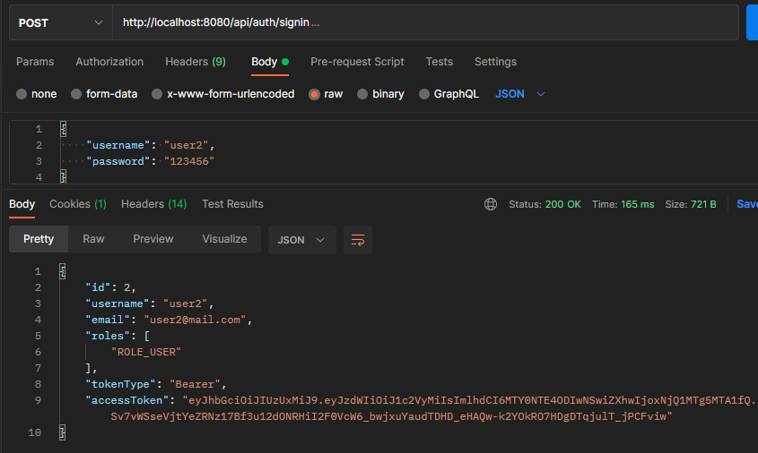

Do request to sign in and see the console:

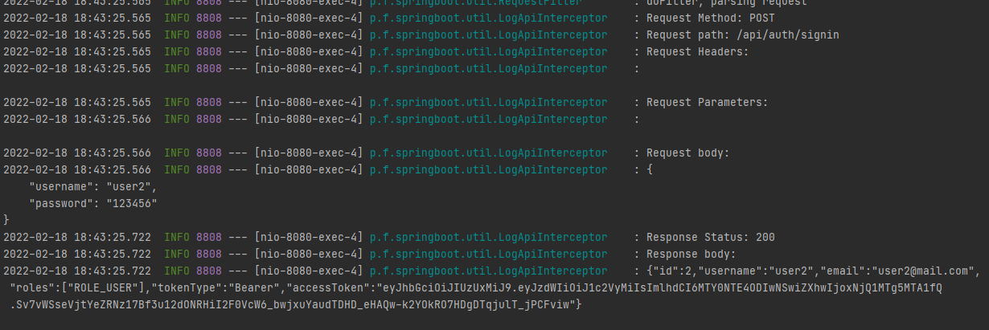

We get the request and response in INFO level

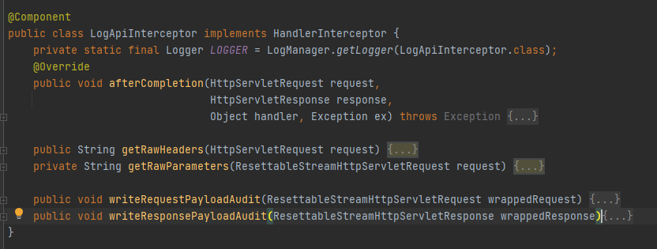

Everything in logging reaches thanks to LogApiInterceptor which has the following methods:







Also used Request filter which allows do filter throw requests and responses. In this method we

are wrapping the request and responses, to reduce the content

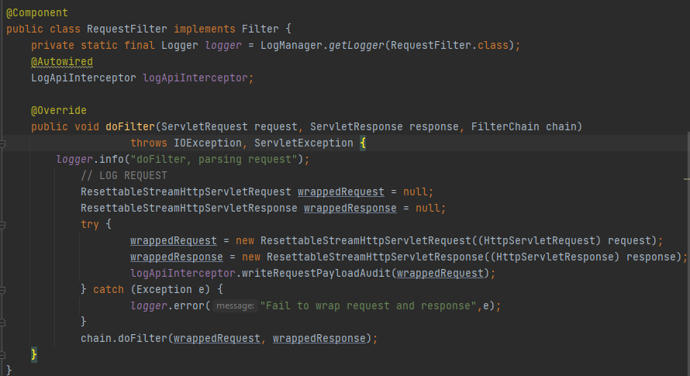

1. Log permission denied response and page not found response in “ERROR” level

Do the request without passing TOKEN of user and get the unauthorized error. 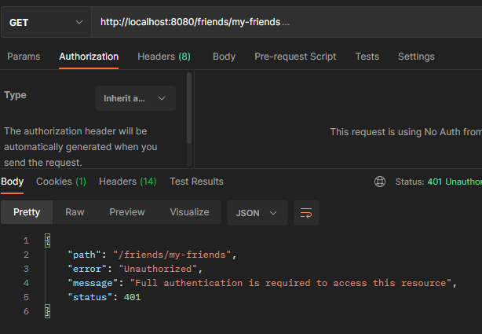





Not found error logging below (we removed “p” from signup in address):

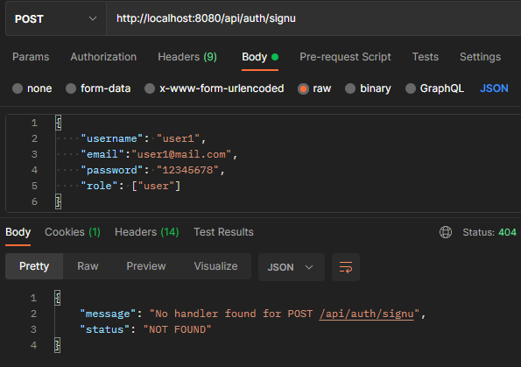

And logging the response



Here the main logger for unauthorized user is component AuthEntryPoint which sends the error message in the certain format

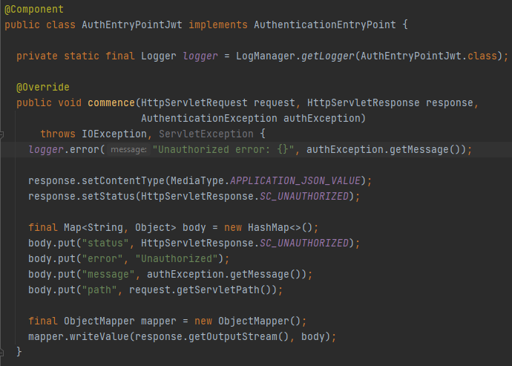

And in Interceptor before you seen the logic to output log for not found pages:

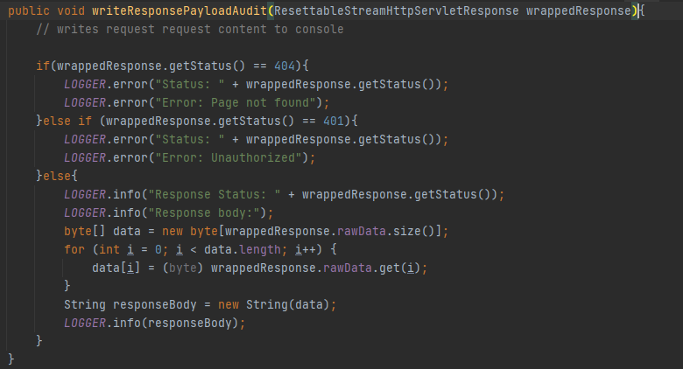

1. Socket server side:
2. Log each connection/disconnection with auth parameters



Logger shows that client is connected to the server. And after user logged in there is the logs in server:

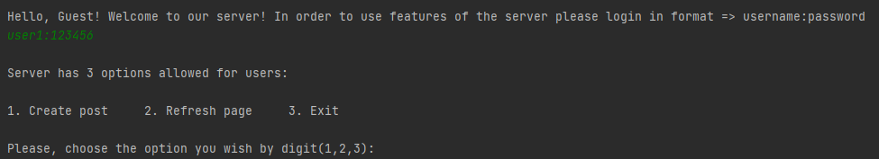

You can noticed that Jdbc connection also was logged.

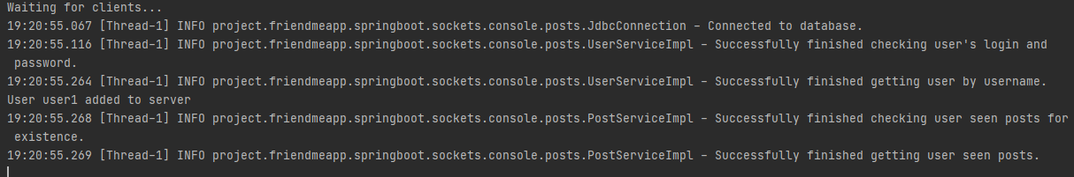

And also let’s disconnect user from server



Output is appropriate.

In order to not make large document as in previous assignment you can the logs code there.

1. Log each update/post request and status (successful, failed, failed in ERROR level)

Here again login the user.

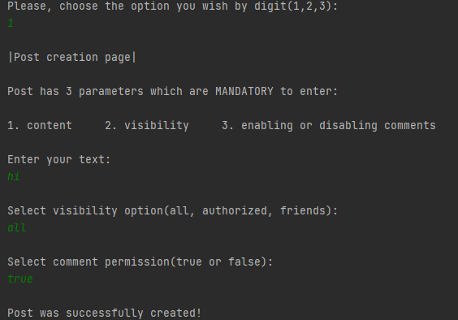

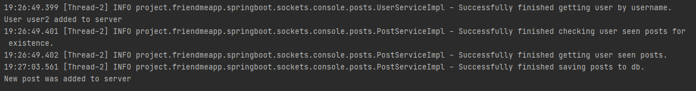

1. Configure roll over (RollingFileAppender)

Configuring roll over is not difficult. We have used “log4j.xml” file for than

1. Roll over daily

Here all logs can be shown in console and logs file using Appenders for them

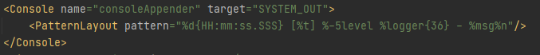

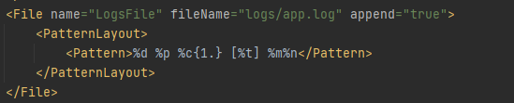

This RollingFile attribute roles the logs daily, it is specified in filePattern [%d{}]

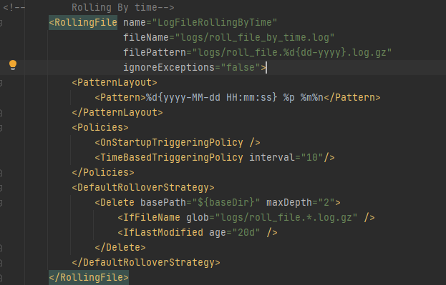

b) Roll over if file size greater than 10 mb

Rolling over based on size works the same:

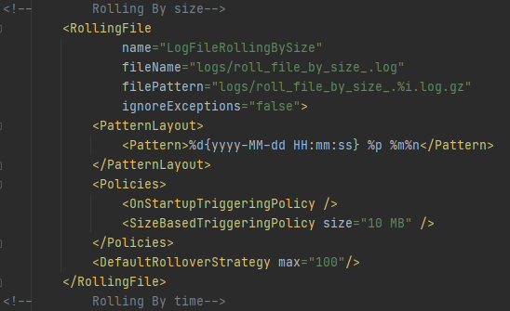

SizeBasedTriggeringPolicy has argument as size, and we specified there 10mb as in requirements. DefaultRolloverStrategy show how much such files can be created.

That’s all.